**LAB: 03**

**TITILE: IMPLEMENTATION OF DFD DIAGRAM**

**Objective:**

Draw the context diagram of online shopping. Also draw DFD-0 and DFD-1.

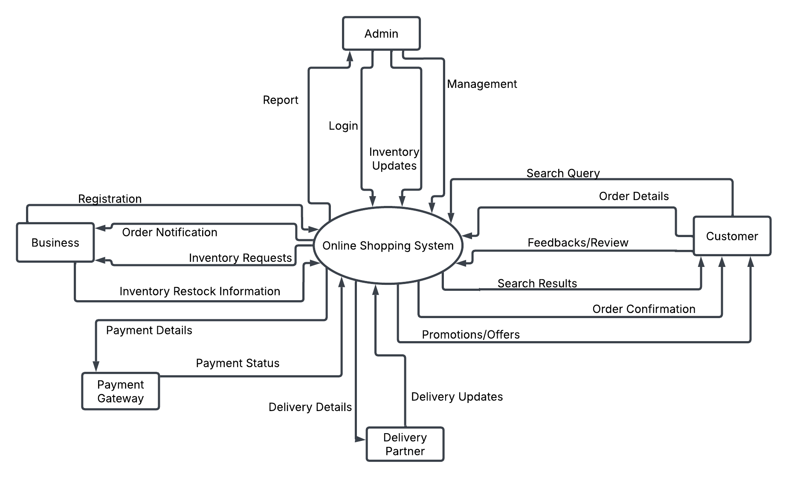DFD-0

Figure 1: DFD-0